# Angular Tutorial for Beginners - Web Framework with Typescript Course

<https://www.youtube.com/watch?v=AAu8bjj6-UI>

Contents

Angular Tutorial for Beginners - Web Framework with Typescript Course 1

Components 2

Manually Creating a Component 2

Importing a Component 4

Starting an Angular App – ng serve 5

LifeCycle Hooks 6

ngOnInit & OnDestroy Hooks 7

Text interpolation 8

Template expressions 9

Component Communication 10

Parent to Child: Using Input Decorator 10

Child to Parent: Using Output Decorator 12

Child to Parent: Using ViewChild 14

Component Styles 15

Special Selectors 16

NG Content 17

Multi-slot Content Projection 18

Template Statments 19

Pipes 21

Date Pipe 21

Multiple Pipe – with UpperCasePipe 22

Custom Pipe 22

Property Binding 24

Attribute binding Colspan vs property binding ColSpan 24

Attribute, Class, and Style Bindings 26

colspan attribute in tables 27

Class Binding 28

Class Binding with boolean expression 28

Binding multiple classes 29

Style Binding 30

Event Binding 31

Custom Events 32

Two Way Binding Connection 33

Template Variables 36

Directives --UPDATEEEE 38

Attribute directive 39

ElementRef – hover over DOM element 40

Dynamic Directive Behavior 41

Structural Directives 42

NgIf 42

NgFor 43

NgSwitch 44

Dependency Injection 45

## Components

* Each component consists of;
  + an HTML template that declares what renders on the page
  + a TypeScript class that defines behavior
  + the CSS selector that defines how the componentis used in our template
  + and optionally, CSS styles applied to the component.
* A component must belong to an NGO module in order for it to be available to another component.
  + 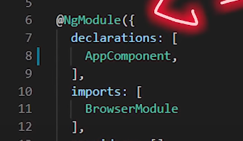
* Why do we use components? There are many reasons but the main ones are,
  + you're able to reuse ourcode so we don't duplicate simplify component based architecture,
  + easy to do error handling,
  + and breaking down the complexity into smaller pieces.
* If you don't have a project, you can create one using g new project name, where project name isthe name of your application.
  + 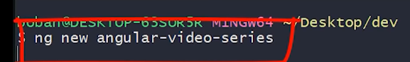

### Manually Creating a Component

* After the import statement, add a component decorator. The decorator “@Component” marks a class is an Angular component which provides metadata that decides how the component is use at runtime.
* 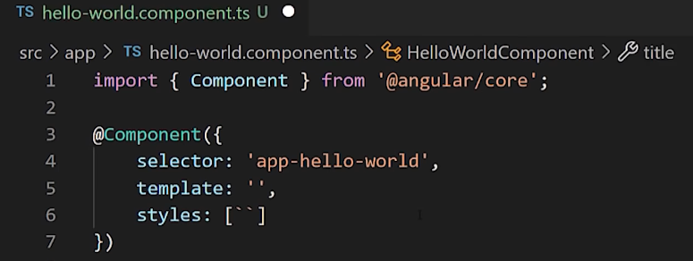
* Choose CSS selector for the component.
  + This is a tag which you will be using in your template files to render your component defined the HTML template that the component uses to display information.
* In most cases, this template is a separate HTML file, but I'll use it within this file.
  + To define a template as external file. Add a template URL property to the component decorator.
  + For a template within the same file, use template property. (As shown at the bottom)
* Select the styles for the components template.
  + In most cases, you will define the styles for acomponents template in a separate file.
  + Again, I will use it within the file to declare the stylesfor a component in a separate pile, or the style URLs property to the Add Component decorator.
  + But for the styles within the component, add styles property, add a class statement that includes the code for the component.
* Here (in this component) we can define properties, methods, catch component lifecycle events, and do dependency injection.
* 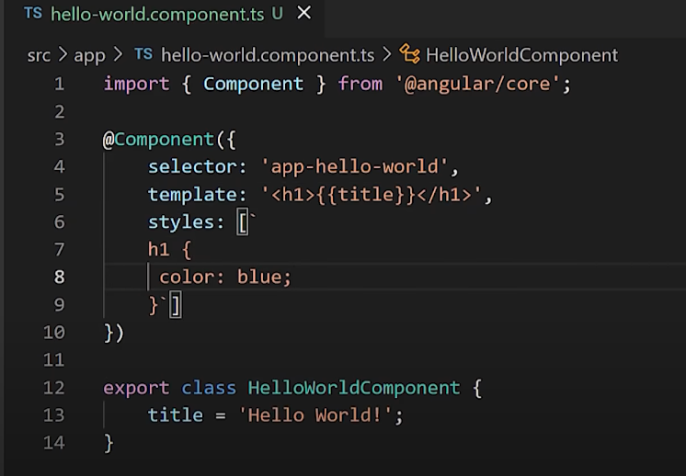
* Now, all the public properties that are defined in the class “HelloWorldComponent” are accessible in the HTML template.
  + And this is one of the most powerful things here,I'll create a title property, and I will include it in the HTML.
  + So the title is available insid ethe html angular compoment

### Importing a Component

* import that new file in the module where you want to use it
* 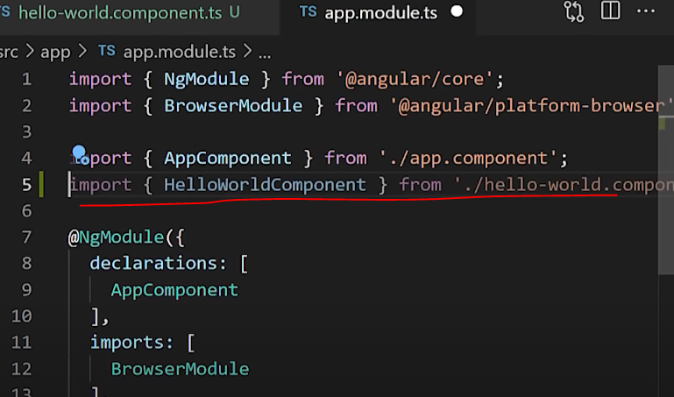
* to make it available for the whole app, import in the root module.
* In order to see our component,we can use our CSS selector inside of our app component or any other component.
* 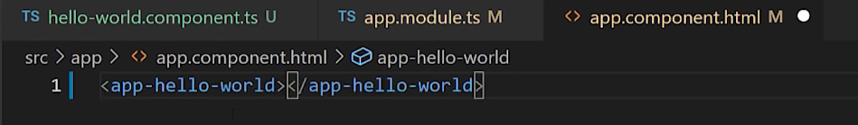
* 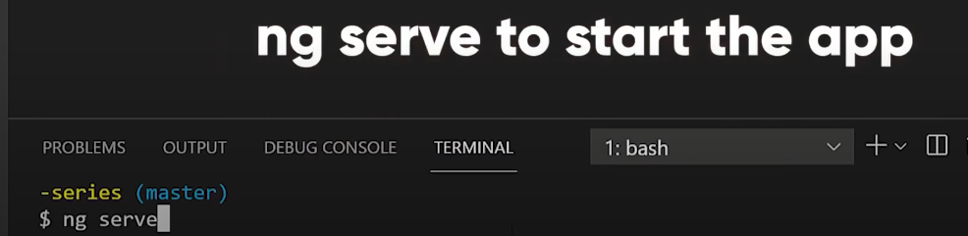
* 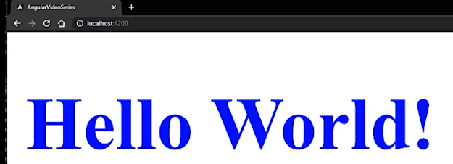

### Starting an Angular App – ng serve







## LifeCycle Hooks

* For example, if you want to fetch some data in this page in your component,you will do that inside of “ngOnInit” lifecycle when a component gets initialized,
* or if you need to clean up your component like remove some subscriptions, you might have to prevent memory leaks, you will do that inside of “ngOnDestroy” lifecycle just before component gets destroyed.
* This is the list of all hooks in exact order how they get initialized, but most use ones are ngOnInit, ngOnChanges, and ngOnDestroy.
* 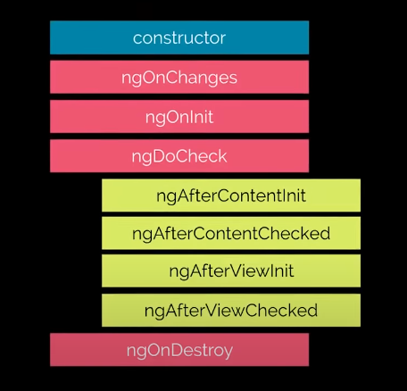

### ngOnInit & OnDestroy Hooks

* first import the OnInit from the angular core
* Next, we want to implement this interface inside of our class.
  + To implement any hook, you just need to add a ng to the interface name, and you will get the method needed for implementation.
  + 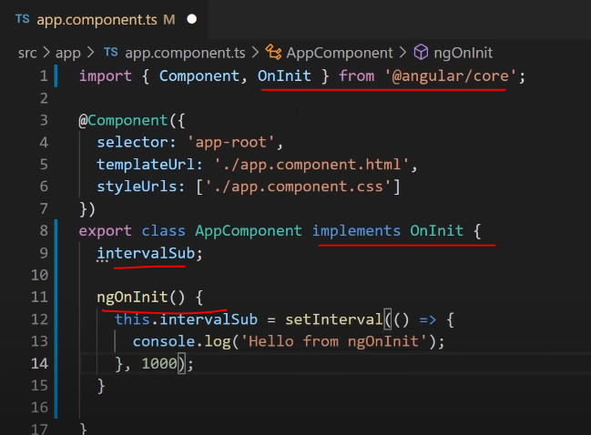
  + So in this case, it's ng on in it,we will create a simple function for logging some values to the console every second. (1000ms = 1second)
  + Now, I will create a property they will save that function so that we can clean it up at the end.
    - The function “setInterval()” belongs to the class property intervalSub which is essentially a null variable or a variable with an assigned function. This is used later on to clear the interval period so that the function stops running.
* In the NG oninit method, let's create a simple set interval method which will make a console log on every second.
  + If you leave our component like this, when the component gets destroyed, our interval method will continue to log to console.
  + To fix this side effect, we need to use the NG ondestroy hook.
    - NEED to use ngOnDestroy to remove the function from continuing to execute
* Import on destroy interface in place the next on in it.
* 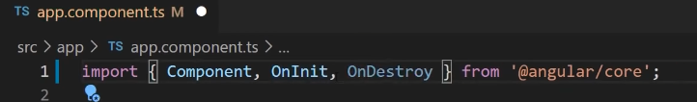
* Now create the NGO ondestroy method and in this method, you need to clean up this interval.
* Simply use a clear interval method with our property passed as an argument.
* And now our component has been cleaned up.
* 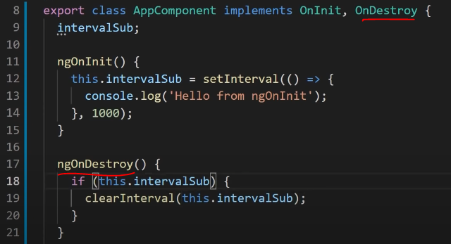
* Using lifecycle hooks, we're going to fine tune the behavior of our components during creation, update and destruction.

## Text interpolation

* Text interpolation in Angular is a one way data binding technique that is used to transfer data from a TypeScript code to an HTML template.
* It uses the template expression in double curly braces {{}}, also known as a mustache syntax to display the data from the component to the view.
  + When dowe need a text interpolation? Every time we want to make something dynamic in our HTML template.
* To illustrate how interpolation works, let's create a new variable in our ts class.
  + You can use interpolation to display the value of this variable in the corresponding component template.
  + 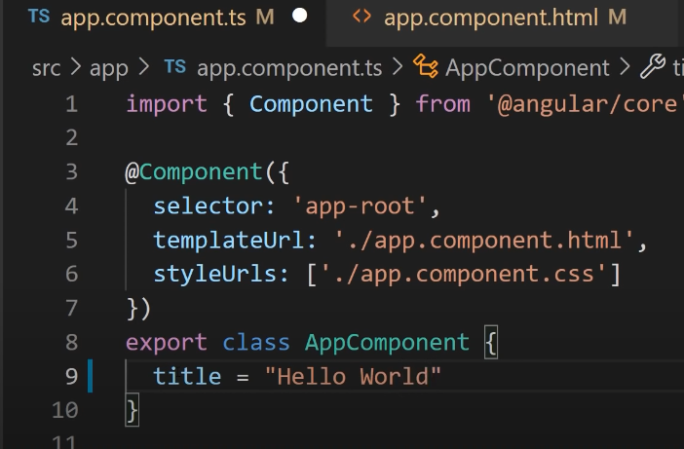
  + 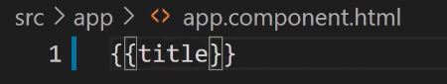
  + 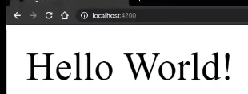
  + Angular replaces title with the string value of the corresponding component property.
  + In this case, the values hello world.

### Template expressions

* A template expression produces a value and appears within double curly braces.
* Angular resolves the expression and assigns it to a property of a binding target.
* 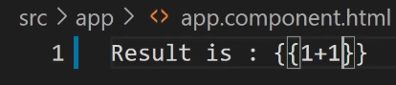
* 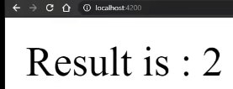
* Template expressions are similar to JavaScript, except you can't use assignments (=, +=, -=).
  + Also operators such as new, typeof or instanceof.
  + You can't use chaining expressions, decrement, or increment operators andsome of the ies 2015 plus operators.
* expressions can also invoke methods.
* So let's create onename of our method that will be get made.
* And in this method, we are returning value for displaying it in our template. In this case, it will be a minimum value. getMin(a,b)
* 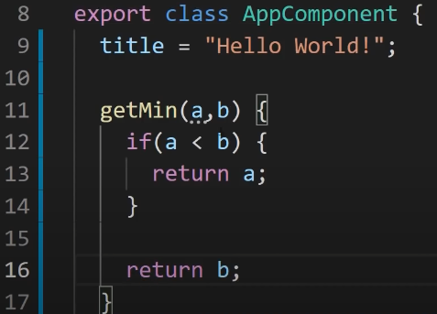
  + Couple of things I want to mention, you should keep application logic in the component as much as possible, where it is easier to develop and test.
  + Also, expressions should finish quickly to keep the user experience as efficient as possible, especially on slower devices.
  + And template expression should not change any application state other than the value ofthe target property.
    - Reading a component value should not change some other displayed values.

## Component Communication

* There are four ways to communicate between the angular components
  + binding using input and output (@Input & @Output)
  + reference by using view child and content (@ViewChild & @ContentChild)
  + provider using services (Service)
  + templates Outlet

### Parent to Child: Using Input Decorator

* First use case is when we want to send data from parent to child using input decorator.
* Input decorator takes the value passed from parent and stores that value in the child property.
* Let me create two components using Angular CLI.
* I will run the following commands ng generate component parent and ng generate component child.
*  
* 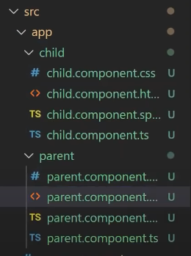
* In our child component, I will import input decorator.
* 
* The name of the input is childMessage of type string
* 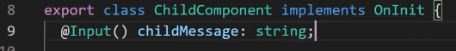
* In a template of the same component, I will display this property which is going to be passed from a parent.
* 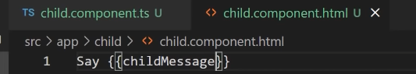
* Now, inside of our parent component in the template, we want to place our child component and to pass the value to the input property we just created.
* The name of the property is the one we defined in the child component, and the value is going to be a Hello message.
* 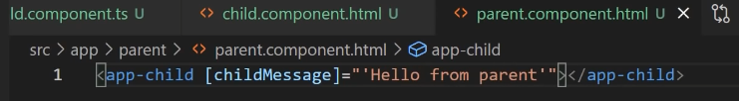
* Next, we want to place our parent component inside of our root component.
* 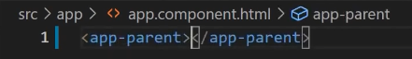
* And if we preview it, we can see their message from parent has been displayed in our child component.
* 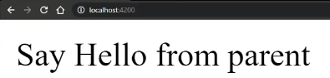

### Child to Parent: Using Output Decorator

* Second use case is when we want to send data from child to parent using output decorator.
* Output decorator marks a property in a child component is a doorway through which data can travel from the child to the parent.
* This approach is ideal when you want to share data. this occurs on things like button clicks, form entries, and other user events.
* 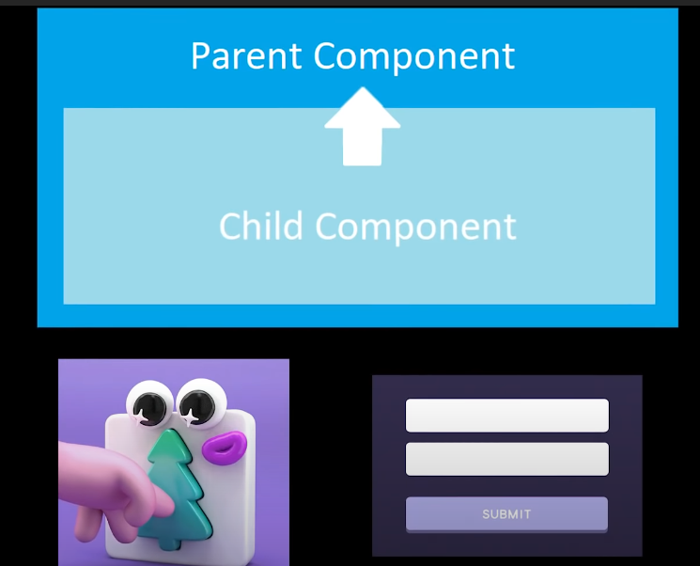 
* To raise an event, an output must have the type of event emitter, which is a class in the angular core that used to emit custom events.
* In the child component, import output decorator and event emitter.
* 
* We declare a message event variable with the output decorator and set it to equal to a newevent emitter.
* And then we create a function named send message that calls a method on thisevent with the message we want to send.
* 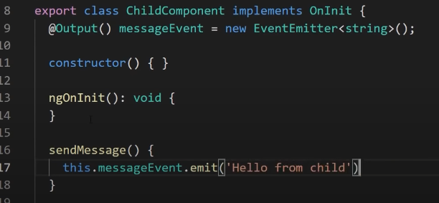
* Lastly, we create a button to trigger this function.
* 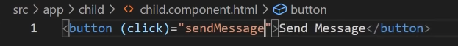
* In the parent, I will create a function to receive the message and I will just simply alert this message for demonstration purposes.
* 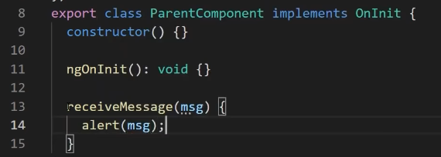
* Now in the parent template, call our function once the event from the child component occurs. And the name of that event is the one that we defined with output decorator.
* 
* 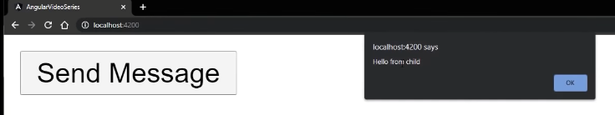
* Compared with all other approaches for communication, binding is the cleanest and the simplest one, it is the most maintainable wait for passing data, as binding is always the most preferable way that Angular developers should consider first.

### Child to Parent: Using ViewChild

* Viewchild allows the child component to be injected into a parent component.
  + It will give the parent access to its properties and functions.
* Each child won't be available to give access until the viewer has been initialized.
* This means we need to implement the afterViewInit lifecycle hook to receive the data from the child.
* First create a message property in our child component.
* 
* Import viewChild and AfterViewInit from Angular core and child component. For our view, child decorator, pass our child component as an argument in named as child.
* Next, implement after view init lifecycle hook.
  + By the way to learn more about Angular hooks,check the part two of this video series
* inside the MG after view init method just alert themessage property of our child so that you can see that we have access to it.
* 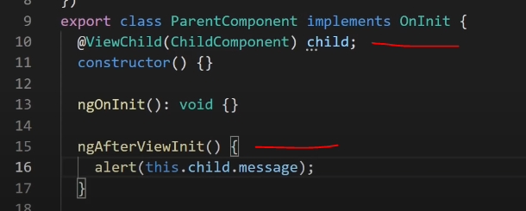
* And if we start our application, you can see that we are displaying a message from the child component.
* 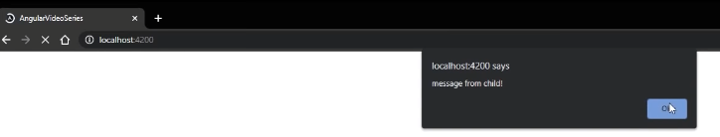

## Component Styles

* css gives us the opportunity to play with a pagelayout, adjust colors and fonts, add effects images, and so on
* There are three ways you can apply style
  + by setting style or styleURLs metadata,
  + inline in the template HTML
  + with CSS imports.
* I created one blank component with only h2 tag in the view to demonstrate all different ways we can style it.
* 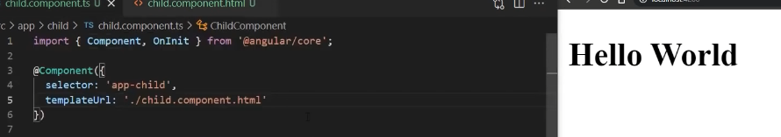
* You can add a styles array property to the component decorator, each string in the array define some CSS for this component
* 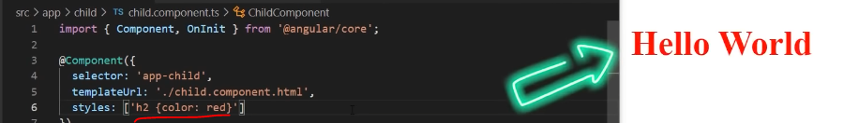
* You can load styles from external CSS files by adding a styles URL property to a components decorator. And now styles from external file are being applied.
* 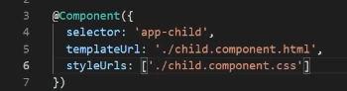
* 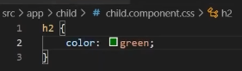
* 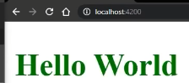
* Next,you can embed CSS styles directly into the HTML template by putting them inside of style tags.
* You can also write the link tags into the components HTML template.
* One note here is to be sure to include the link stylesfile among the assets to be copied to the server when building.
* You can also import CSS files into the CSS files using the standard CSS import rule.
* I usually use this approach to import variables.
* Reminder, these styles apply only to this component.
* So if you held h1 tag in a childor parent component, it won't be applied there.
* By default view encapsulation is said to emulatedand emulates the behavior of the Shadow DOM by pre processing and renaming CSS code toeffectively scope the CSS to the components view.
* We can remove these additional CSS selectors bysetting encapsulation to none.
* And now our styles are being applied globally.
* Global styles are by default defined in the style CSS file, and you can define more global styles in the angular JSON file.
* Another thing is that if you're building with the CLI, you can write style files in sass,less or stylus, and specify those files in the component style URLs metadata, be the appropriateextension as in the following example.

### Special Selectors

* Now let's talk about special selectors.
* Use the hostpseudo class selector to target styles in the element that hosts the component is opposite totarget elements inside the components template.
* For example, we can write the following code.
* We can style host styles with the given selector by using the function form as the following.
* And if you add active class to host component, you can see that styles are being applied.
* Now let's talk about host context.
* Sometimes it's useful to apply styles based on some conditionoutside of the components view.
* For example, a CSS theme class can be applied to the documentbody element.
* And you want to change how your component looks based on that.
* The following example applies a background color style to allh2 elements inside of the component.
* Only if ancestor element has the CSS class theme light.
* Now if you go to root element, add theme like class, you can see those styles.
* And that's it.

## NG Content

* ng content uses the content projection to take HTML of another component and to displayed inside itself.
* When do you want to use ngcontent? anytime you want to inject any kind of HTML into a component, you can do so ng content.
* I have two components child and root component to demonstrate this feature inside the childcomponent, I will create some static content. So I'll add an h2 title. And below that title,I want to show that dynamic content.
* So I will create an ng content tag.
* 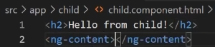
* Users of this component can now project their own message into the component.
* To do that, let me insert a child inside of our root componentand I will pass paragraph in a message.
* As you can see, the ng content element is a placeholder that does not create a real DOM element.
* 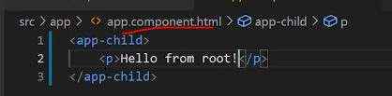
  + The root app component html has a child component (app-child)
    - The app-child shown further above has ng-content which serves a placeholder so that when the root app uses the child component, new html can be injected in place of the ng content placeholder
    - This is shown that the <p> element with “Hello from root!” message is defined in the root app
  + 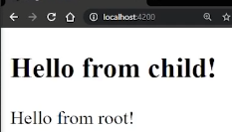

### Multi-slot Content Projection

* Now, except single a component can have a multiple slots.
* Each slot can specify a CSS selector that determines which content goes into that slot.
  + This pattern is referred to as **multi slot content projection.**
* You can accomplish this task by using the Select attribute of ngcontent inside of our child component.
  + add one more Angie content add, we can make our component to be like a question and answer card.
  + So in the first entry content, add question selector and put a second edgy contentadd answer selector.
  + 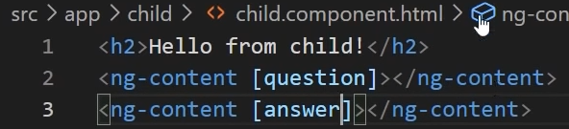
  + Now, we can use the selectors to send different content.
* In our root component, I will create a h3 title question selector, and I will type this question text.
* Below, I will create a paragraph get an answer selector, and I will type an answer text.
* 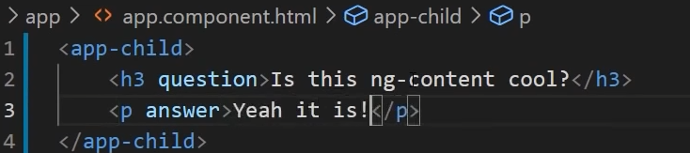
* 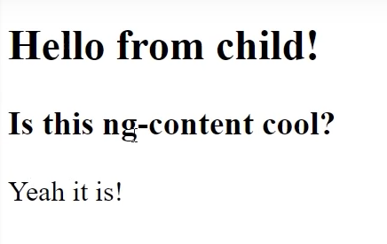
* Also, there are a couple other ways to create multi slot content projection.
  + But we haven'tcovered conditionals yet.
  + As you can see, it's really easy to create reusable dynamic components.
  + This approach can be used for much more complex user interfaces.
  + But I showed you this simple example to understand the concept.

## Template Statments

* A template statement is something that responds to an event raised by a target like an element component or directive.
  + So it's the same thing as if someone is calling you, which is an event and you're answering that phone call, which is the response and in our example,template statement.
* It commits side effects as it changes the fields in the component.
* Now, I will show you how to update class properties using a template statement.
* I have a blank component and in our template, I will create a Boolean property named showtext in a value of false.
* Below that, I will create a method named toggle text,it's not going to return anything at this point. All we are going to do here is to toggle our showtax value on every method call.
  + Usually, we would use this kind of property to toggle the state in the view, but we haven't covered conditionals yet.
  + 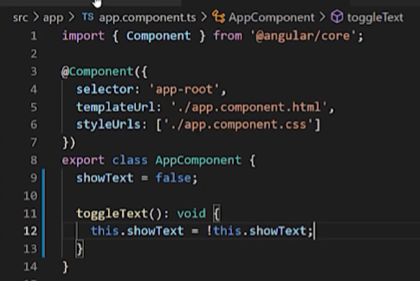
* So in the template,I'm going to create a button which will respond on a click event and it will call this toggle method. Below that I will adjust the state or show tax property.
* 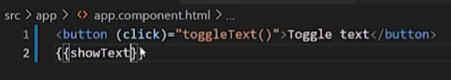
* And now when I click the button, you can see that it toggles the its value using template statement.
* 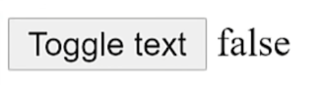
* 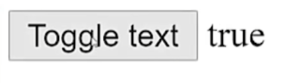
* And in this example, toggle text is template statement.
  + This statement context may also refer to properties of the templates own context.
* In the following example,toggle text takes the templates own event object as an argument.
* 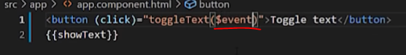
* 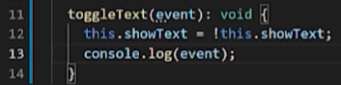
* If you log that object,you can see that it contains various information about a target and the event that occurred.
* 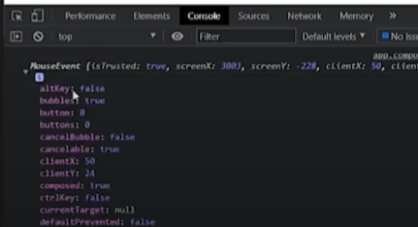
  + Passing arguments can be very useful when you're submitting the forms or looping through arrays,and you need to access a specific element.
* One odd here is that the context of a template statement can be the component class instance, orthe template. Because of this, template statements cannot refer to anything the global namespace,such as window or document. For example, template statement can’t call console log or math max.

## Pipes

* pipes are simply functions you can use in your templates to accept any input value and return a formatted value.
* Angular provides building pipes for typical data transformation like Date pipe, UpperCase pipe, currency pipe, percent pipe, and similar.

### Date Pipe

* In my app component, I will define a property with a value of new date.
* 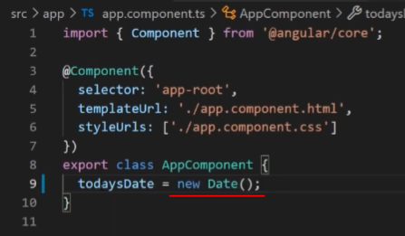
* If we just display our date object in our template, you can see what kind of format we get. It's not very user friendly.
* 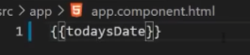
* 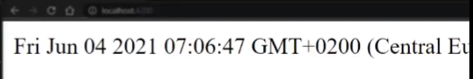
* To apply a pipe use the pipe operatorwithin a template expression along with the name of the pipe, which is the date for the builtin date pipe now this is my more readable.
* 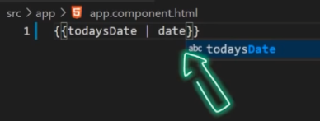 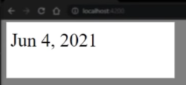
* One note here, date pipe is executed only when it detects a pure change to the input value.
* A pure change is either a change a primitive input value such as a string, number, Boolean or symbol, or a change object reference, such as date, array, function,or object.
* If you still don't like the output format of your data, you can finetune it by using optional parameters.
* There are predefined options like short or long, and others or you can customize it completely.
* 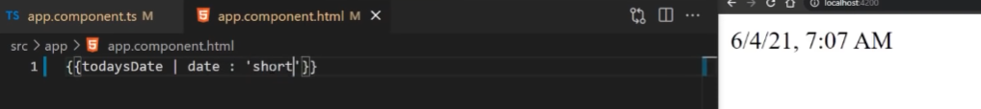
* 
* For example, I’ll write four upper case Es, four upper case Ms, one lower case d, and one lower case y.
* 

### Multiple Pipe – with UpperCasePipe

* You can also change multiple pipes as well, you just add another pipe operator in a pipe name.
* 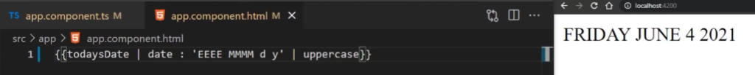

### Custom Pipe

* Now, we can create custom pipes as well. Let's create a simple greetings pipe that will concatenate hello to pass name. I'll use Angular CLI to generate this file for me.
* So type ng generate pipe and the name is greeting’s pipe.
* 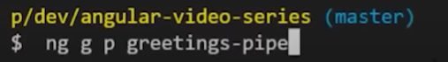
* In our pipe, we have boilerplate code generated
* You can see that pipe decorator has been imported with a name property, which we can use to call our pipe in our templates.
* 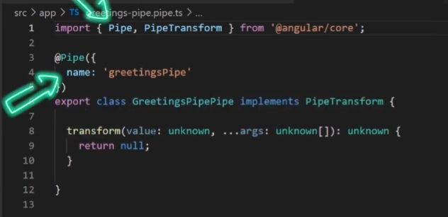
* Also, there is a pipe transform interface which needs to be implemented. This interface requires the transform method to be implemented.
* And this method receives a value passed from a template. In our case it will be a string.
* And the second parameteris for optional params From pipe itself.
* return type in our case is going to be a string.
* Now all we're going to do here is to concatenate Hello with the passed in word and return that.
* 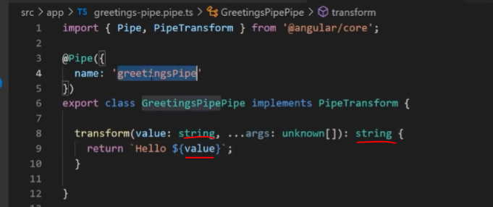
* Now in our template, we can call our custom pipe with the greetings pipe name that we defined,and I will pass world is our string. Now that's how you create a custom pipes.
* 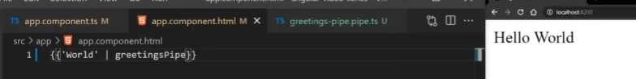
* Angular pipes are very simple, but useful functionality provided by Angular, and you will use them a lot.
* Once again for a detailed list of all pipes check the documentation link from the description.
* <https://angular.io/guide/pipes>

## Property Binding

* Property binding moves a value in one direction.
* It goes from class property to target element property.
* Property binding in Angular helps you set values or properties of HTML elements or directives.
* With property binding, you can do things as toggle button functionality, set paths programmatically, and share values between components.
* To bind the source property of an image element to a components property, place a target source in the square brackets followed by an equal sign, and then the property.
  + The property here is item image URL.
  + 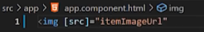
* Declare the item image URL property in the class, in this case, app component.
  + 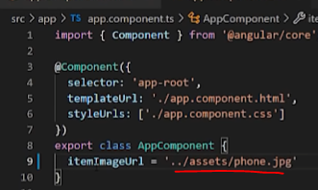

### Attribute binding Colspan vs property binding ColSpan

* A common point of confusion is between the attribute colspan and the property colSpan.
  + Notice that these two names differ by only a single letter. S vs s
* If you wrote something like this, you'll get the template parse error
  + 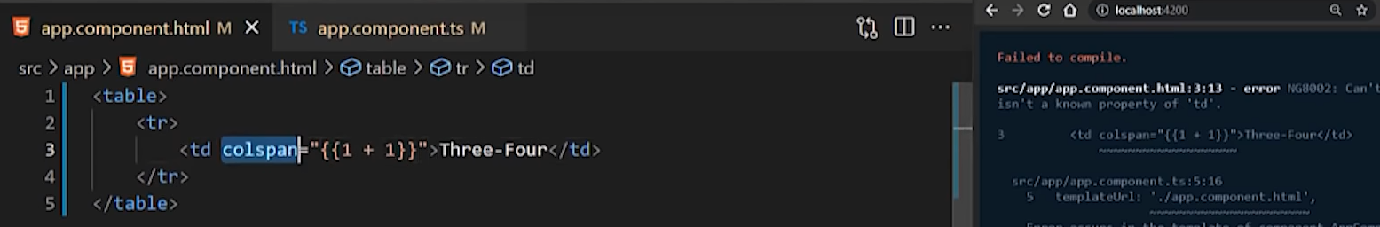
  + interpolation and property binding can set only properties, not attributes.
  + Attributes are attributes of the html tag without square brackets around them
  + Properties are inside the html tag with square brackets around them
* Instead, you'd use property binding and write it like this.
  + 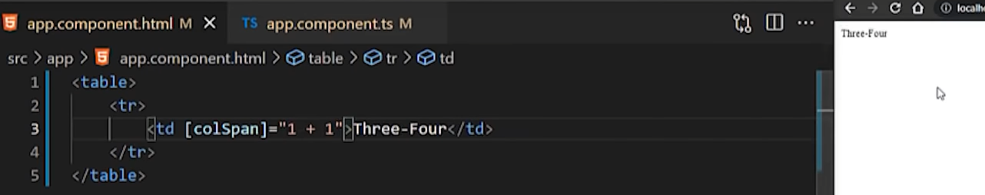
* 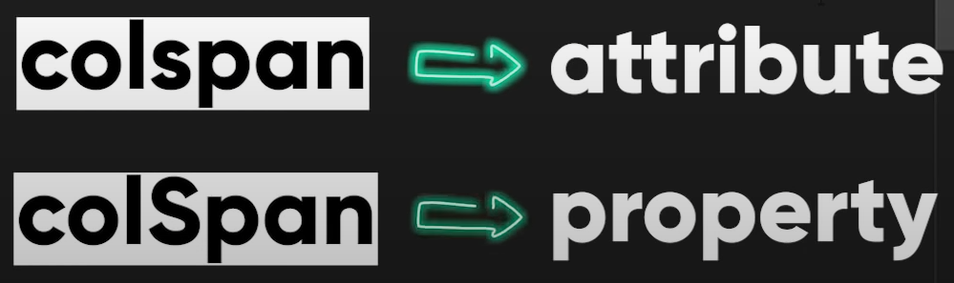 
* Another example is disabling a button when the component says that it's unchanged.
* 
* To disable advanced functionality depending on a boolean value, binding down disabled property to a property in the class that's true or false.
* Because the value of the property is unchanged,it's true in the app component Angular disables the button.
* 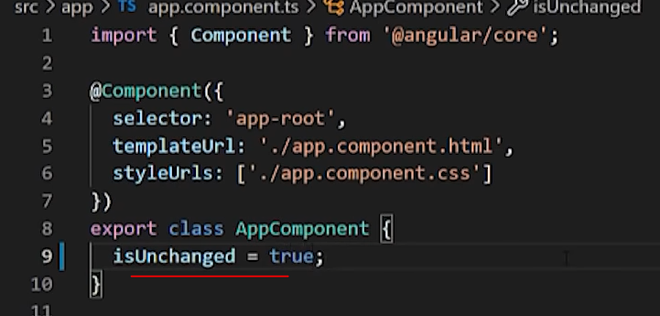
  + 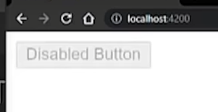
  + Disabled property is true so angular disables the button
* Often, interpolation and property binding can achieve the same result.
* The following binding pairs do the same thing.
* 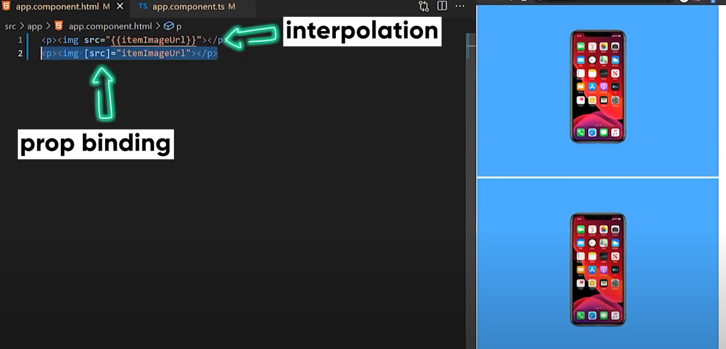 
* One note, evaluation of a template expression should have no visible side effects.
  + You shouldn't be assigning anything in the template expression or using increment or decrement operators.
* If you had an expression that changed the value of something else that you were binding to,the change of value would be a side effect.

## Attribute, Class, and Style Bindings

* Using these bindings, you can improve accessibility, dynamically style your application, and update classes on the fly.
* First, let's talk about attribute binding.
* Attribute binding in your app helps you set values or attributes directly.
  + It is recommended that you set an element property with a property binding whenever possible.
  + However, sometimes you don't have an element property to bind.
  + In those situations, you can use attribute binding.
* attribute binding syntax resembles property binding, but instead of an element property between brackets, you proceed the name of the attribute with prefix “attr” followed by a dot.
* Then you set the attribute value with an expression that resolves to a string.
* 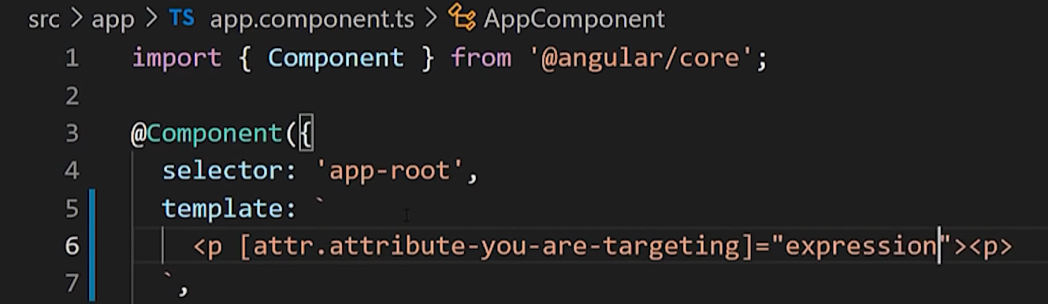

### colspan attribute in tables

* Another common use case for attribute binding is with the colspan attribute in tables.
* Minding the colspan attribute helps you keep your tables programmatically dynamic.
* Depending on the amount of data that your application populates a table with, the number of columns their row span could change.
* To use attribute binding with the td attribute colspan, specify the colspan attribute by using this syntax.
* set attribute colspan equal to an expression.
* In this example, we bind the call span attribute to the expression one plus one.
* 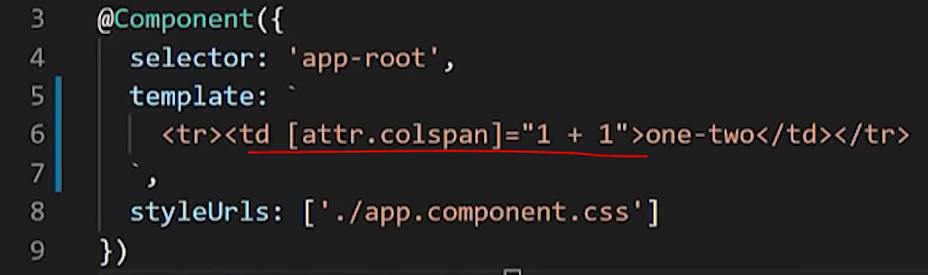
* This binding causes the table row to span two columns.
* 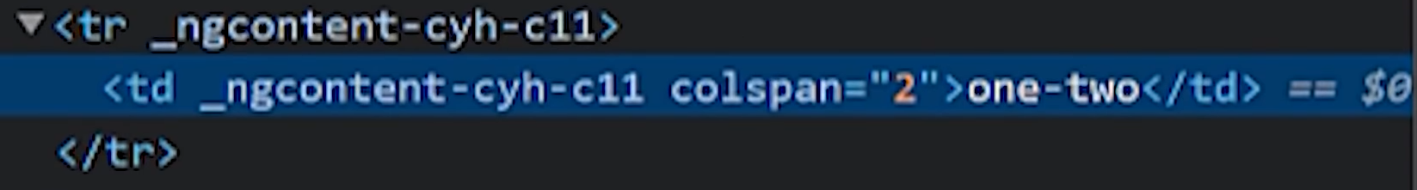
* Sometimes there are differences between the name of property and an attribute.
* colspan is an attribute of table row, while colspan with the capital S is a property
* when using attribute binding, use colspan with a lowercase s.
* For more information on how to bind to the cost and property, check out the video about the property binding.

## Class Binding

* You can use class binding to add and remove CSS class names from an elements class attribute.

### Class Binding with boolean expression

* To create a single class binding use the prefix class followed by a dot and the name of the CSS class.
* Angular adds the class when the bound expression on sale is true.
* 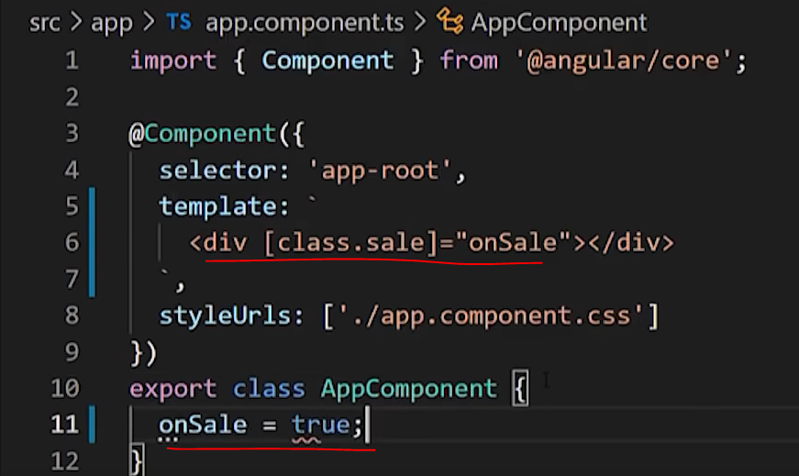
* 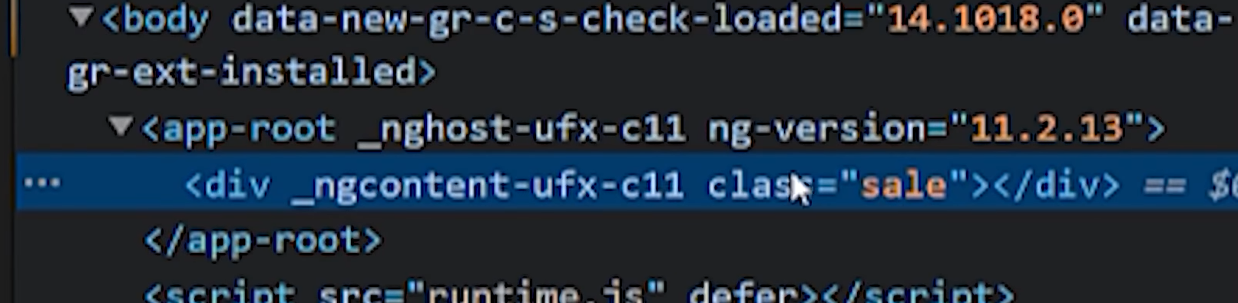
* And it removes the class when the expression is faulty. With the exception of undefined.
* 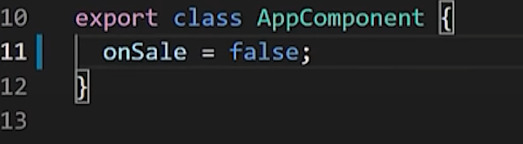
* 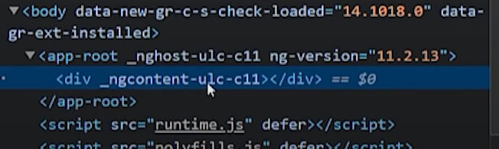

## Binding multiple classes

* To bind the multiple classes, use class set to an expression.
* The expression can be one of a space delimited string of class names.
* 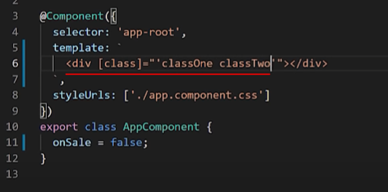
* 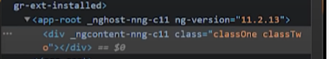
* Key Value Multi-Class binding
* An object class names as the keys and the policy expressions as the values
* 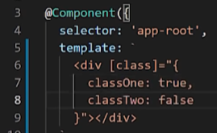
* 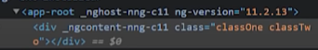
* an array of class names.
* 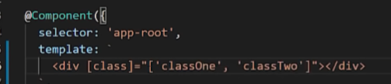
* 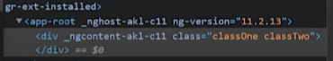
* With the object format, angular adds a class only if its associated value is true.

## Style Binding

* You can use style binding to set stylesdynamically.
* To create a single style binding. Use the prefix style followed by a dot.
* 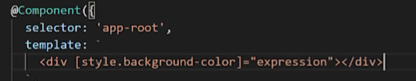
* in the name of the CSS style property, angular sets the property to the value of the bound expression,which is usually a string.
  + Optionally, you can add a unit extension like M or a percentage, which requires a number type.
  + You can write a style property name in either dash case, or camel case.
  + 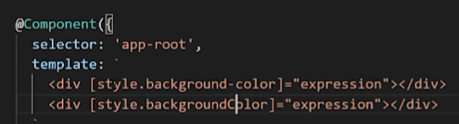
* To toggle multiple styles, bind to the style attribute the style expressionthe style expression can be one of a string list of styles.
* 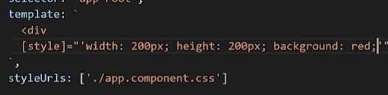
* 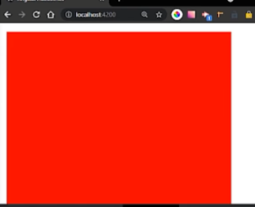
* Or an object with style names is the keys in style values as the values
* 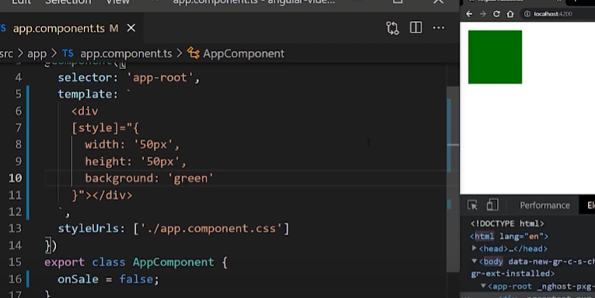
* and note that binding in array to style is not supported.

## Event Binding

* Event binding allows you to listen for and respond to user actions such as keystrokes, mouse movements, clicks and touches.
* To bind an event you use the angular event binding syntax.
* The syntax consists of an event name within parentheses to the left of an equal sign ina template statement to the right.
* 
* In this example, the event name is click and the template statement is OnSave.
* 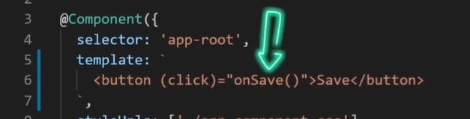
* We can now define the OnSave method in the class.
* 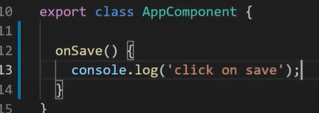
* And once we click our button, that event has been bound and our method is executed.

### Custom Events

* We can also bind to custom events.
* To demonstrate that I'll create an item details component.
* 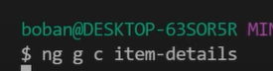
* In this component, I'll create an event emitter with output decorator, which exposes our property to parent components.
* 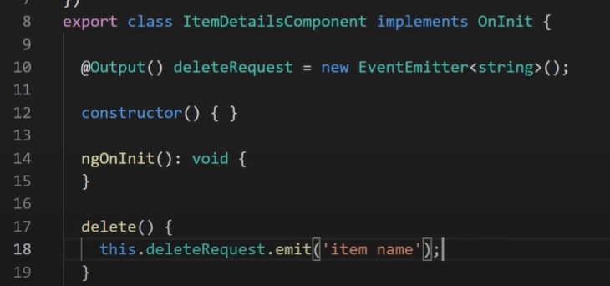
* Then I'll create a delete dummy method, which will just emit our property once we call it.
* Now, I'll define a button and bind this method to a click event.
* 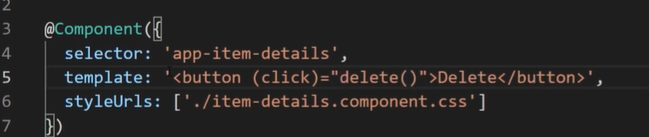
* Next, I'll place our item details component in our app component.
* And I will bind to the Delete request custom event that we just created.
* I'm calling the lead item method.
* And I'll use the event parameter to catch the string sent with this event.
* 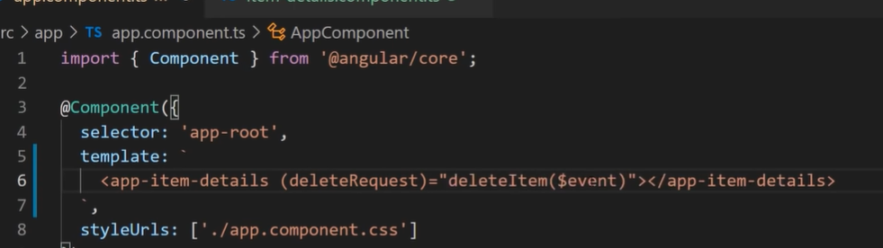
* And now I'll define the Delete item method in our class and just log what we got.
* 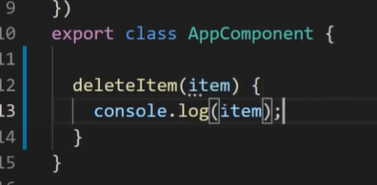
  + So now the item is passed in as an argument and the item is console logged
* And that's how you bind to custom event.

## Two Way Binding Connection

* Now let's see two way binding connection.
* Two Way binding is the concept of sharing and giving.
* Why to a binding? binding gives components in your application a way to share data,
* use two way binding to listen for events and update values simultaneously between parent and child components.
* Angular’s two way binding syntax is a combination of square brackets and parentheses.
  + This syntax combines the brackets of the property binding with the parentheses of event binding.
* I'll create a sizer component.
* 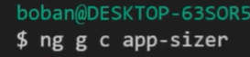
* In our component, I will define a size value property in a size change event.
* The size property is an input, so data can flow into the size or component.
* The sizeChange event is an output, which allows data to flow out of the size or component to the parent component.
* 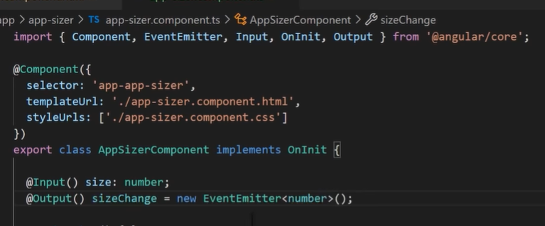
* Next, there are two methods; dec() to decrease the font size and inc() to increase the font size.
* These two methods use Resize to change the value of the size property within min max value constraints. And to emit an event that conveys the new size value.
* 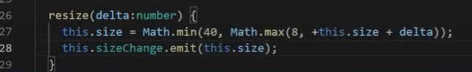
* In the sizer component template, I'll create two buttons that each bind the click event to the inc() and dec() methods.
  + When the user clicks one of the buttons, the sizer component calls the corresponding method.
* Both methods inc() and dec() call the resize method with a plus one or minus one, which in turn raises the sizeChange event with the new size value.
* And below them, I'll add a label which displays the size property in dynamically a bit its own font size.
* 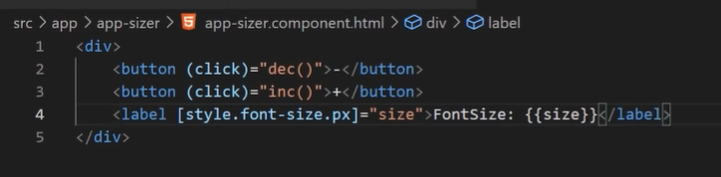
* In our root app component, I'll include an app sizer component, and I will use two way binding to bind font size PX property to the size or component.
* And below that, I'll add a div which will utilize this property to adjust its text size.
* 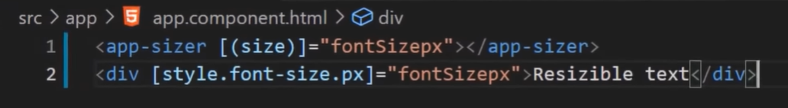
* In the app component, the app component “fontsizepx” establishes the initial size or component size value by setting the value to 16.
* 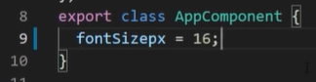
* Clicking the button at this the app component font size px, the revised font size PX value updates style binding, which makes the display text bigger or smaller.
* 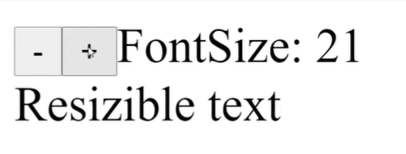
* 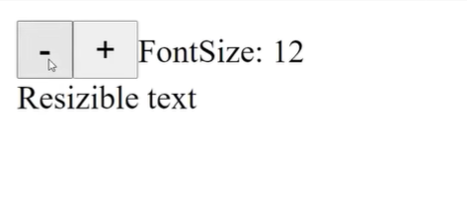
* The two way binding syntax is shorthand for a combination of property binding and event binding.
* The sizer component binding a separate property binding and event binding is as follows.
* 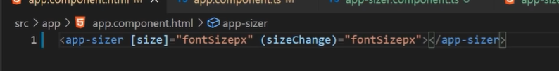
* The event variable contains the data of the size or component size change event.
* Angular assigns the event value to app component “fontsizepx” when the user clicks the buttons.
  + To use two way binding with form elements, we need ng model which I will cover in the form section.

## Template Variables

* template variables helps you to use data from one part of a template in another part of a template.
* It's a variable that is created in and indentifies a component or element within the template itself.
* With template variables, you can perform tasks such as respond to user input, or finally tune your applications form
* In the template, you use the hash symbol to declare a template variable.
* The following template variable phone declares a form variable when an input element,
* you can refer to a template variable anywhere in the components template.
* 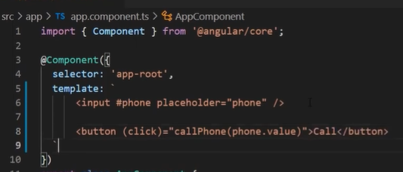
* Here a button further down the template refers to the form variable.
* Now we can define the cellPhone method and log the passed in value, which is the actual value of the input.
* 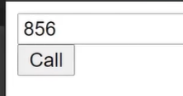 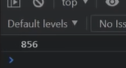
* So what is the template variable scope, you can refer to a template variable anywhere within its surrounding template.
* Structural directives such as ngIf and ngFor which we'll cover in the later videos, or ng template, act as a template boundary, you cannot access template variables outside of these boundaries.
* So, can we access variables in a nested template?
  + an inner template that can access template variables that the outer template defines.
* In the following example, changing the text in the input changes the value in the span because Angular immediately updates changes to the template variable ref one.
* 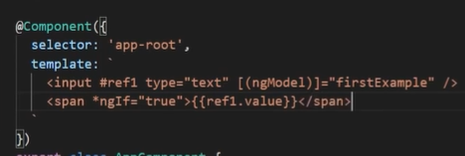
* 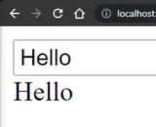
* In this case, there's an implied ng template around a span and a definition of the variable is outside of it.
* So is the same thing as binding explicitly like this.
* 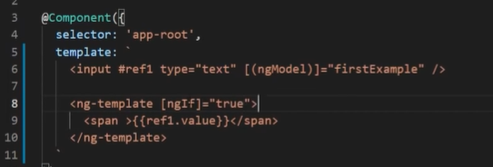
* However, accessing that template variable from outside the parent template doesn't work. its the same as writing the following
* 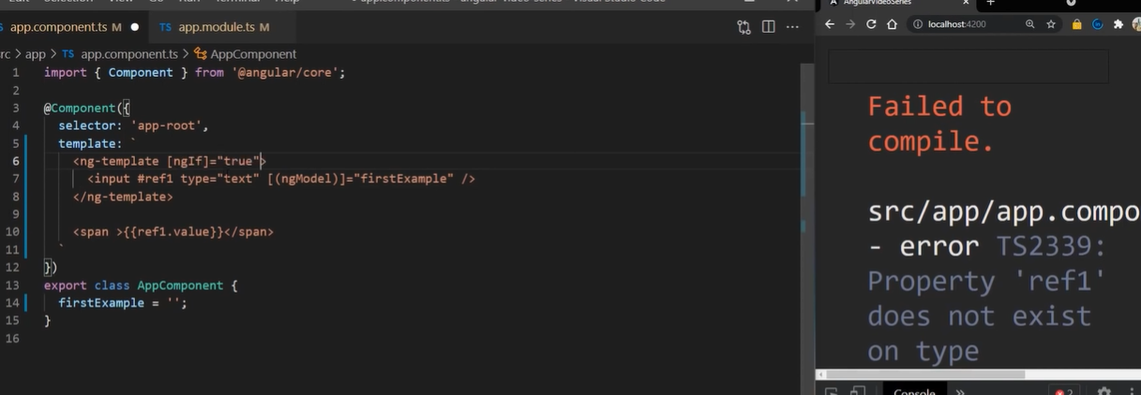
  + Ng-template defines a template boundary so the template variable #ref1 is not accessible in the outer template

## Directives --UPDATEEEE

* Now, let's discuss directives is the same as if you are a CEO of the company.
* And you are givingdirectives to your employees how to behave in what to do in certain situations.
* What are directives.
* directives are classes that add additional behavior to elements in your Angular application.
* with Angular built in directives, you can manage forms, lists, styles, and what users see.
* The different types of Angular directives are as follows.
* Components directives with a templatethis type of directive is the most common directive type attribute directives.
* directivesthat change the appearance or behavior of an element component or another directive.
* Structural directives, directives that change the DOM layout by adding and removingDOM elements.
* Today, we are talking about built in attribute directives.
* Attributedirective listens to and modify the behavior of other HTML elements, attributes, properties,and components.
* Many angii modules such as router module and forms module, they findtheir own attribute directives.
* The most common attribute directives are as follows.
* mg classadds and removes a set of CSS classes and G style adds and removes its set of HTML styles.
* And modeladds two way data binding to an HTML form element.
* How to add and remove classes with NGO class.
* You can add or remove multiple CSS classes simultaneously with mg class.
* To add orremove a single class use class mining rather than entry class.
* When the element you'd like to style,add Angie class and set it equal to an expression.
* In our class.
* Let's define you special as trueBecause is special is true and reclass applies the class of special to the diff.
* To use NGO class with a method add method to the component class.
* In the following example, set current classes sets the property current classes with an object thatadds or removes three classes based on the true or false state of three other component properties.
* Each key of the object is a CSS class name.
* If a key is a true and your class as the class if a keyis false, and re class removes the class.
* Boolean values are hard coded just for demonstration.
* In the template, added the N g class property binding to current class to set the elementsclasses.
* And now we can preview our classes.
* Now let's talk about mg style.
* You can use mg styleto set multiple inline styles simultaneously based on the state of the component.
* To use edgy styleand the method to component class.
* Add empty object current style.
* In the following example,set current style says the property current styles with an object that defines three stylesto set elements styles, and an energy style property binding the current styles.
* For thisuse case, angular applies the styles upon initial annotations.
* And in case of changes.
* To do this,the full example called set current styles initially with NGOs in it.
* And the last one in today's video is NGO model, you can use the NGO model directiveto display a data property and update that property.
* When the user make changes.
* Input forms module and add it to NGO modules import list.
* I'll create a label and an input for this example.
* Add an mg model binding of an HTML form element and set it equal to theproperty here its name.
* Now, if you define property inside of our component class,you can see how mg model directive adds two way data binding to our input.
* This mg model syntax can only set a data bound property.
* When you write an Angular component,you don't need a value accessor or mg model if your name, the value and evenproperties according to Angular to a binding syntax.
* And that's all for this section.

## Attribute directive

* import directive decorator from core and implement that decorator with selector property.
* For me, it's going to be app highlight.
* 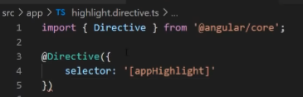
* Next, we want to export our class.
* And the last thing we want is to import that in our declarations array in app module.
* 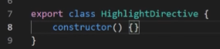
* That's our directive boilerplate code, which can also get with the command ng generate directive highlight.

### ElementRef – hover over DOM element

* Import element ref from Angular core.
* 
* Element ref grants direct access to the host DOM element through its native element property.
* Add element ref in the directive constructor to inject a reference to host DOM element, the element to which you apply app highlight.
* Add logic to the highlight directive class that sets the background to yellow.
* 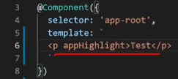
* To use the highlight directive, add a paragraph element to the HTML template with the directive as an attribute.
* Angular creates an instance of highlight directive class and inject in the reference to the paragraph element into directive constructor, which has the P elements background style to yellow.
* 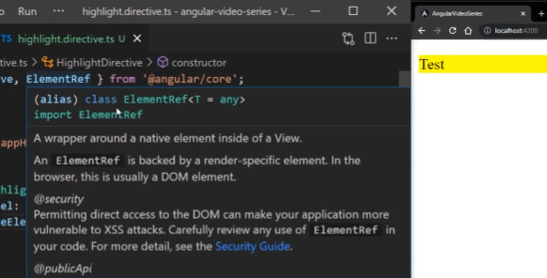
* Now, let's see how to detect when a user mouse's into or out of the element and to respond by setting or clearing the highlight color.
* Import host listener from Angular core.
* 
* Add it to event handlers that respond when the mouse enters or leaves, each with a host listener decorator.
* 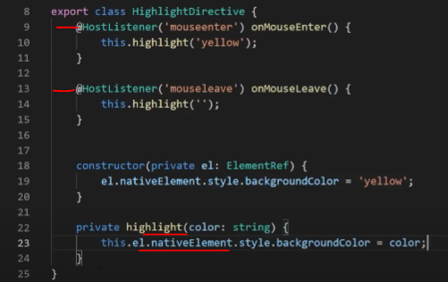
* With the host listener decorator, you can subscribe to events ofthe DOM element that hosts an attribute directive.
* The paragraph in this case, the handlers delegate to a helper method highlight that says the color on the host DOM element L.
* The background color appears when the pointer hovers over the paragraph element and disappears as the pointer moves out.
* 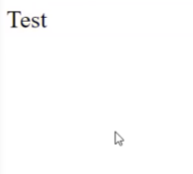 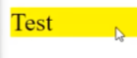

### Dynamic Directive Behavior

* Now, let's see how we can make the directive dynamic, to be able to use it at different places with different colors.
* In highlight directive Ts File, Import input from Angular core, add an app highlight input property.
* 
* The input decorator adds metadata to the class that makes the directive apphighlight property available for binding.
* In app component Ts add a color property to the app component. To simultaneously applied the directive and the color.
* 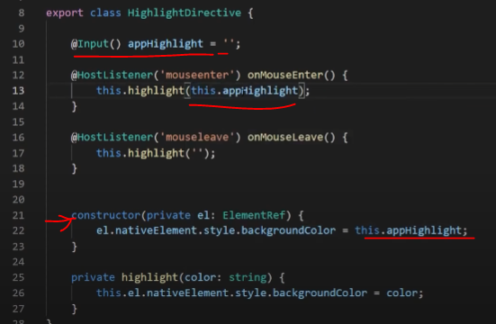
* Use the property binding with the app highlight directive selector setting to equal to color.
* 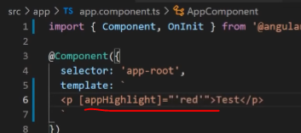
* The app highlight attribute binding performs two tasks applies the highlighting directive to the paragraph element and sets directive highlight color with the property binding.

## Structural Directives

* Structural directives are responsible for HTML layout.
  + They shape or reshape the dome structure, typically by adding removing and manipulating the host elements to which they're attached.
* NgIf conditionally creates or disposes of sub views from the template
  + You can add or remove an element by applying an NgIf directive to a host element.
  + When Ngf is false, angular removes an element and its descendants from the DOM.
  + Angular then disposes of their components, which frees up memory in resources
* NgFor; repeat a note for each item in a list.
* NgSwitch; a set of directives that switch among alternative views.

### NgIf

* to add or remove an element by the NgIf, the condition expression such as “isActive” in this example.
* When it is active, expression returns a true value NgIf as the div to the DOM.
* 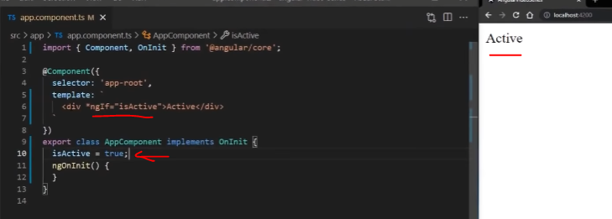
* When the expression is false, NgIf removes the div from the DOM.

### NgFor

* You can use the NgFor directive to present a list of items.
  + Let's create an array of objects with the name property in it.
* Define a block of HTML that determines how Angular renders a single item.
* to list your items assigned the shorthand “let item for items” to NgFor the string lead item of items instructs Angular to do the following.
* Store each item in the items array in the local item looping variable, make each item available to the template HTML for each iteration.
* 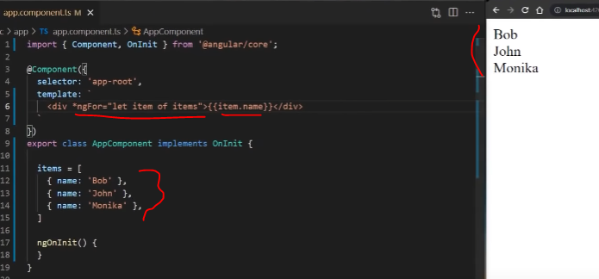
* Translate lead item of items into ng template around the host element.
* Repeat the Ng template for each item in the list.
* By the way, you can get the index of energy for in a template input variable in use it in the template in the NgFor, add a semicolon and let i equals to index to the shorthand.
* 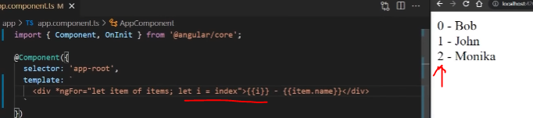
* The following example guys the index in a variable named I in these days it within the item name.

### NgSwitch

* NgSwitch displays one element from among several possible elements based on a switch condition.
  + Angular puts only the selected element into the DOM.
* NgSwitch is a set of three directives.
  + NgSwitch, an attribute directive that changes the behavior of its companion directives
  + NgSwitchCase structural directive that adds its element to the DOM when it's bound value equals to switch value and removes its bound value when it doesn't equal the switch value.
  + NgSwitchDefault structural directive that adds its element to the DOM when there is no selected energy switch case
* I'll modify the items array to be just a single item.
* On an element such as a div, add NgSwitch bound to an expression that returns the switch value such as a name.
  + Though the name value in this example is a string, the switch value can be of any type
  + bind to NgSwitchCase and ngSwitchDefault on the elements for the cases.
* 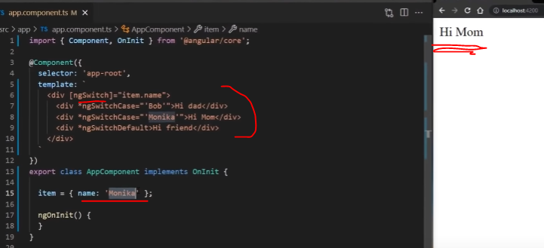
* And now depending on the value of the item name rendering on the page changes.
* If it didn't provide a case for the name value, default will be executed.

## Dependency Injection

* dependencies are services or objects that a class needs to perform its function.
* dependency injection, or di is a design pattern in which a class request dependencies from external sources rather than creating them.
  + You can look at it as if you're adding an extension to your browser, or adding an app to a phone.
  + Once you add it, you provide yourself with the new functionalities and features nice extension.
* Let's create a service which we can inject in our components.
* Create a new file with the name log.service.ts.
* Import injectable decorator from Angular core.
* 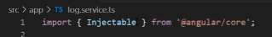
* And then for provided in metadata add root value, which means that we are going to provide the service in the root of the application and that is visible throughout the application.
* export our log service class and inside of this service, we want to add our log message method, which will just log past messages.
* 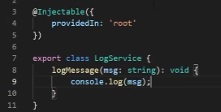
  + For clarity in meeting ability, it is recommended that you define components and services in separate files
* now inject our log service into the app module file in providers array.
* Injecting service results in making them visible to a component.
* 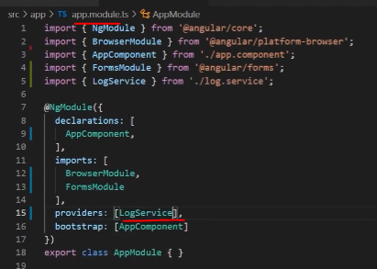
* to inject a dependency in components constructor, supply a constructor argument with dependency type.
* The following example specifies the lock service, the app component constructor to type of log service is log service.
* 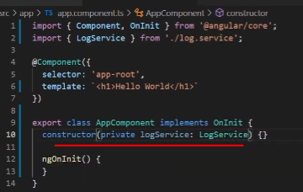
* Now we can reference our log service in our component and call our method from it
* it should pass our message and as you can see it's being executed as expected.
* 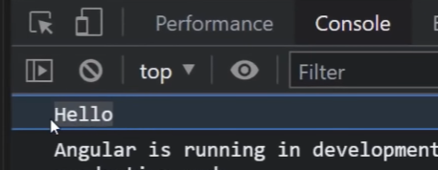

### Third Party Library

* We can use this approach to inject third party libraries in other modules that are available in the angular framework.
* So let's inject render to module which is used for custom renderingand updating the DOM.
* Import render to from Angular core and injected inside the constructor.
* Also, we will need element ref, which we can use for referencing our DOM elements,or the host component in our case.
* 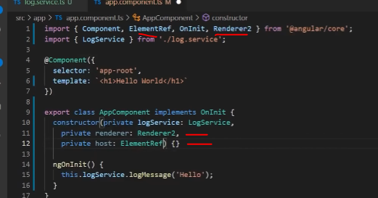
* Now inside the NG on init lifecycle, call the set style method of the renderer and set the color of host native element to red.
* This method changes the color of our components text
* 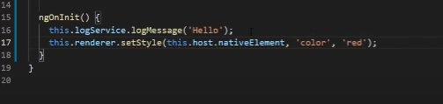
* And as you can see, with the dependency injection, we get access to more features and methods.

## Routing

* The angular router is a core part of Angular platform.
* It enables developers to build single page applications with multiple views.
* In the navigation between these views, we can compare routing of our obligations with navigating a plane. Pilot says the flight coordinates in our case route path, and the plane lands on the desired location or desire page in our app.
* Oftentimes, planes carries goods or cargo and routes carry params info in data.
  + And unfortunately, some things do get crashed or lost.
  + And for route sometimes we get 404
* To use the angular router, an application needs to have at least two components so that it can navigate from one to the other.
* To create a component using the CLI, enter the following at the command line, where first is the name of your component, and G generate component.
* 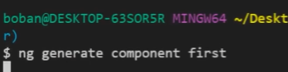
* First, repeat this step for a second component or give it a different name.
* 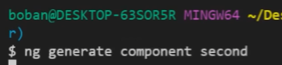
  + Here the new name is second.
* This guide works with a CI generated Angular application.
* If you're working manually, make sure that you have base href would slash in the headof your index HTML file.
  + This assumes that the app folder is the application route and that uses slash
* create a new module for routing named app dash routing dot module.
* We find const routes which is type of routes.
* Here we will define our paths and components.
* 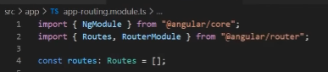
* Inside NgModule imports array add router module in call for route module it routes passed as argument, then export the router module so it can be imported into the route module.
* At the end, define the app routing module classimported app routing module into app module and add it to the imports array.
* 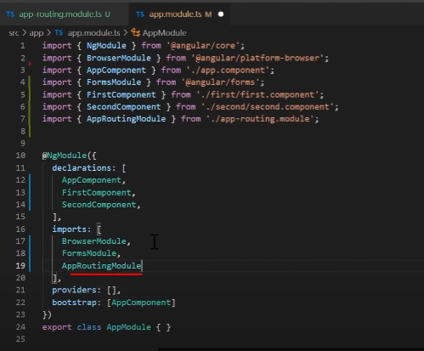

### Define Routes

* Now define your routes in your routes array.
* 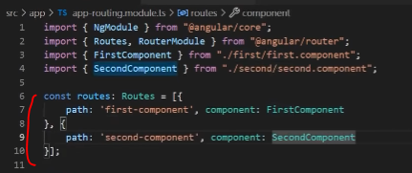
* Each route in this array is a JavaScript object that contains two properties.
  + The first property bath defines the URL path for the route.
  + The second property component defines the component that Angular should use for the corresponding path.
* Now that you have defined your routes, you can add them to your application.
* First, add links to the two components.
* assign an anchor tag that you want to add the route to the router link attribute.
* 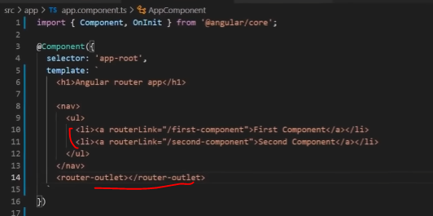
  + Set the value of the attribute to the component to show when a user clicks on each link.
* Next, update your component template to include router outlet.
  + This element informs Angular to update the application view with the component for the selected route.
  + You can add router link active activity if you want to style active link.
* One Note; the order of routes is important because the router uses a first match wins strategy when matching routes.
  + So more specific routes should be placed about less specific routes.

### Pass Information between Routes

* Often is a user navigator application, you want to pass information from one component to another.
* To do so you use the activated route interface.
* First input router and activated route in para map to your component.
* inject an instance of activated route by adding it to your applications constructor.
* Update the NGO own init method to access the activator route and track the ID parameter.
* 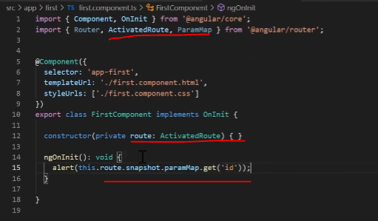
* Now we need to adjust our routes to pass the ID params as well.
* In that, add semi colon and name of your parameter.
* 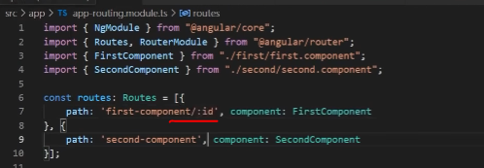
* And then we can add ID values to our links.
* 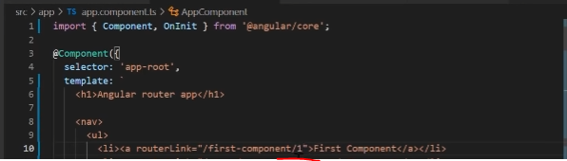
* That's how you pass in retrieve data from one component to another.

### Wildcard Route

* A well functioning application should gracefully handle when user attempts to navigate to a part of your application that doesn't exist.
* To add this functionality to your application. You set up a wildcard route.
* The angular route selects this route anytime the requested URL doesn't match any router paths.
* To set up a wildcard route, add the following code to your routes definition.
  + For the component property, you can define any component in your application.
  + Common choices include an application specific page not found component.
  + But here I'm just redirecting to the first component.
* 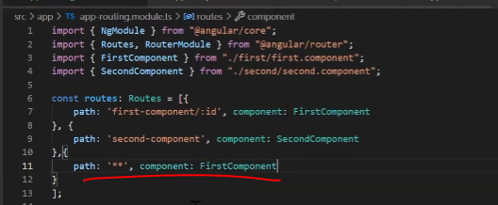
* And now if you navigate to any random path, it will always give us first component.
* As your application grows more complex, you may want to create routes that are relative to the component other than your route component.
  + These types of nested routes are called child routes.
  + This means you're adding a second router outlet to app because it is in addition to the router outlet in app component.
* In this example, there are two additional child components child a and child b.
* here first component has its own nav, and a second router outlet in addition to the one in app component.
* 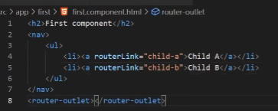
* Also, I'm going to create two child routes with the router links of child a child B and give it a second router link.
  + Now I'll create two additional component with Angular ccli in named their child a component and child B component.
  + Each other route is like any other route, in that it needs both a path and a component.
* The one difference is that you place child routes in a children array within the parent route.
* Now if you navigate to any of child routes, we get the corresponding child component.
* 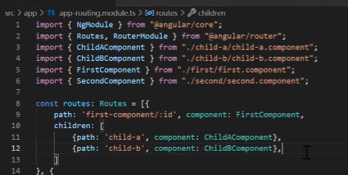

### Route Guards

* Use route guards to prevent users from navigating to parts of an application without authorization.
* The following route guards are available in Angular;
  + CanActivate, CanActivateChild, CanDeactivate, Resolve, and CanLoad
* create a service for your guard.
* 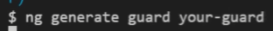
* In your guard class, implement the guard you want to use
* the following example users can activate to guard the route.
  + Now depending on your logic, it can return true or false.
  + Usually it's checks if the user is logged in, or does he have privileges to access the page
* in your routing module, use the appropriate property in your routes configuration
* 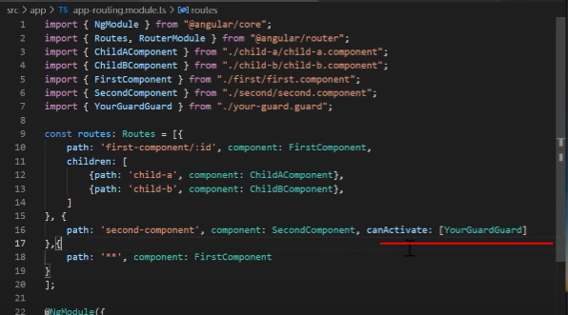
* here, CanActivate tells the router to mediate navigation to this particular route.
* Now, if you set the guard too false, we can't access the route. Otherwise, we can.
* And that's all for routing for this section.

## Angular Forms – Template-Driven Forms

* ANgular supports two design approaches for interactive forms.
* template driven forms are suitable for small or simpler forms.
* While reactive forms are more scalable and suitable for complex forms.
* This tutorial shows you how to build a form from scratch.
* First, import forms module in your app root module.
* 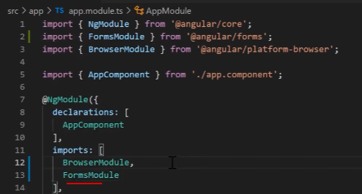
* Let's first build our Pet class which defines a data model reflected in our form.
* It will have three properties ID, name, and species.
* 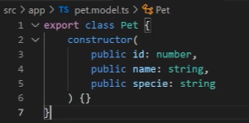
* Now let's import our class in the app component.
* Define a species in species array.
* Now create a model from the Pet class and pass the values for our path. Here we're using dummy data.
  + But in your real app, you would use a service to get the data from the API and to save it.
* Also, let's add submitted property, which will change depending on the state of the form and on submit method.
* 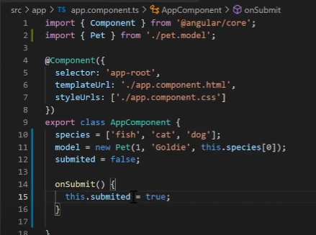
* Next in our HTML file, we will create a form that reflects our data model.
* Create a form and inside two divs for two fields.
* First, we'll be naming input.
* And I'm adding a label and required attribute to our input.
* And the second one will be a cell Act,which will loop through an array of species to show all the values from the array.
* Same as for input, I'm adding a label for our select.
* And also I'll add the required attribute.
* Then I will use mg for tillow to do all the values and display them.
* 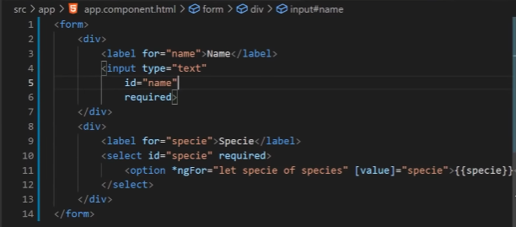
* If you run the application right now, you'll see the list of species in the selection control.
* 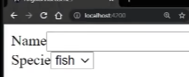
* The input elements are not yet bound to data values or events. So they are still blank and have no behavior.
* The next step is to bind the input controls to the corresponding pet properties with two way data binding so that they respond to the user input by updating the data model, and also respond to programmatic changes in the data by updating the display.
* The NgModel directive declared in the forms module, lets you bind controls in your template driven form to properties in your data model.
* Add the NgModel directive using two way data binding syntax for the name use model dot name.
* And for species use model dot species value.
* 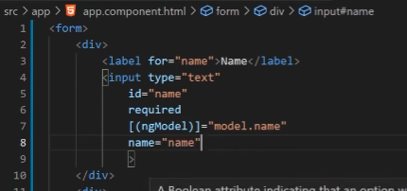
* When you use NgModel on element, you must define a name attribute for that element.
* Angular uses the assigned name to register the element with the NgForm directive attached to the parent form element.
* So in order to register our form, add a template reference variable. use the value of NgForm.
* The pet form template variable is now a reference to the NG g form directive instance that governs the form as a whole.
* 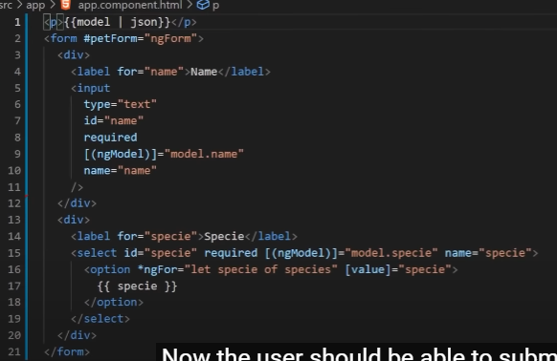
* In order to test our application plays the model object in our template with a JSON pipe.
* Now if you update your foreign films, you will see that model is being updated.
* 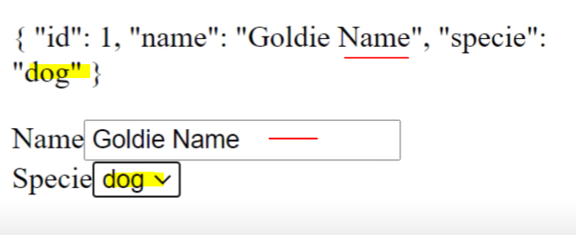

### Response after submitting form

* Now the user should be able to submit this form after filling it, create a submit button on the bottom.
* the submit button at the bottom of the form does nothing on its own, but it does trigger a form submit event because of its type Submit
* To respond to this event, Take the followingsteps.
* bind the forms Ngsubmit event property to the platform component on submit method.
* Use the template reference variable petform.
* To access the form that contains the submit button and create an event binding.
* You will bind the form property that indicates its overall validity to the Submit buttons disabled property.
* 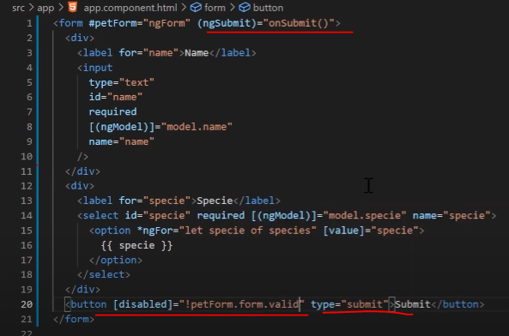
* run the application now.
  + Notice that the button is enabled.
  + Although it doesn't do anything useful yet.
* Delete the name value.
* This name is the required rule so disable the submit button.
* 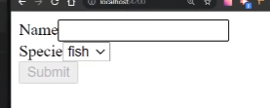
* To show a response to form submission, you can hide the data entry area and put something else in its place.
* Wrap the entire form in a div and bind it's hidden property to the app component submitted property.
* The main form is visible from the start because the submitted property is false. until you submit the form as this fragment from the app component chose
* 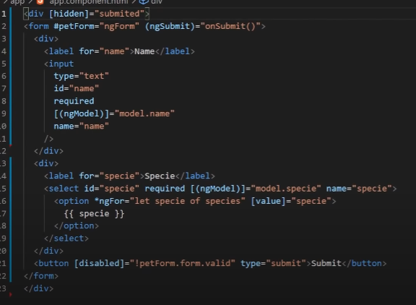
* to show something else while the form is in submitted state add the following HTML below the new div wrapper and add the properties that you updated in the edit button.
* 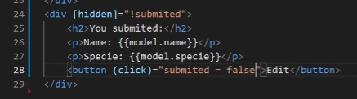
* If the user wants to update the fields again.
* And now let's preview how it works.
* That's all about template driven forms.
* 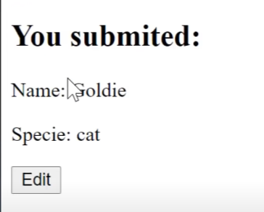

## Angular Forms – Reactive Forms

* Reactive forms provide a model driven approach to handling form inputs, whose values change overtime.
* Each change to the form state returns a new state, which maintains the integrity of the model between changes.
* Let's add basic form control.
* To use reactive form controls, import reactive forms module from Angular forms package and added to your NGO modules import array.
* 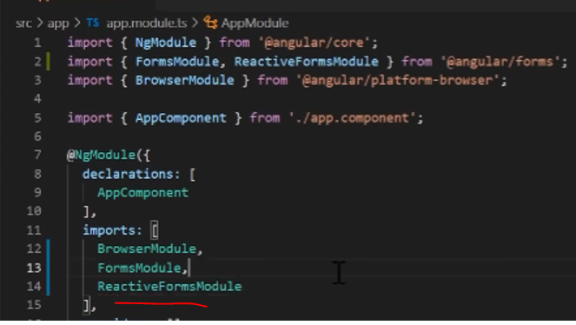
* To register a single form control, import a form control class and create a new instance of formcontrol to save as a class property.
* Use the constructor of form control to set its initial value, which in this case is an empty string.
* 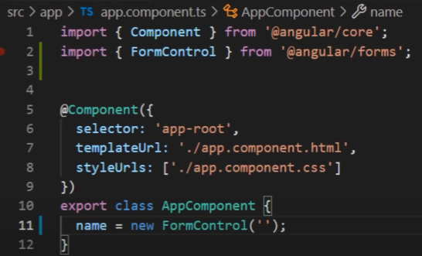
* By creating these controls in your component class, you get immediate access to listen for update and validate the state of the form input.
* After you create a control in the component class, you must associate it with a form control element in the template with a form control using the form control binding provided by form control directive, which is also included in the reactive forms module.
* Using the template binding syntax, the form control is now registered to the name input element in the template, you can display the value in the following ways
  + through the value changes observable, or can listen for changes in the forms value in the template using async pipe, or in the component class using the subscribe method, or with the value property, which gives you a snapshot of the current value.
* The following example shows you how to display the current value using interpolation.
* In the template.
* 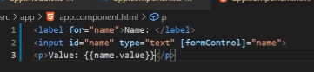
* The displayed value changes as you update the form control element.
* 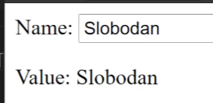
* Reactive forms have methods to change it controls value programmatically, which gives you the flexibility to update the value without user interaction.
* The following example adds a method to the component class to update the value of the control to Nancy using the set value method.
* 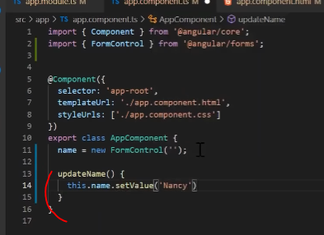
* Update the template button button to simulate a name update.
* 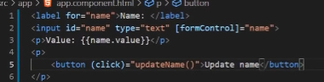
* When you click the Update name button, the value entered in the form control element is reflected as its current value.
* The form model is the source of truth for the control.
* So when you click the button, the value of the input is change within the component class, overriding its current value.

### Form Group

* Form stabilty contains several related controls.
* Reactive forms provide two ways of grouping multiple related controls into a single input form.
  + First way of form group, defines a form with a fixed set of controls that you can manage together.
  + And second way of form array defines a dynamic form where you can add and remove controls at runtime.
* import the form group and form control classes from the angular forms package.
* Create a property in the component class name profile form, and set the property to a new form group instance.
* to initialize the form group, provide a constructor with an object of named keys mapped to their control.
* For the profile form add to form control instances with the namesfirst name and last theme.
* The individual form controls are not collected within a group.
* 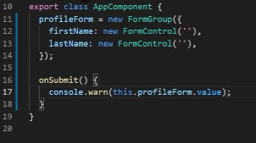
* After you define a model, you must update the template to reflect the model in the view.
* I'm adding two inputs and two labels that match our model.
* The form control name input provided by the form control name directive binds each individual input to the form control defined in the form group.
* The form comm directive lessons for the Submit event, immediate buy the form element and emits an mg submit event that you can bind to a callback function.
* Add an mg submit event listener to the form tag with the on submit callback method.
* The onsubmit method captures the current value of profile form.
* Here, you will just log the form value.
* The submit event is emitted by the form tag using the native Dom event, you trigger the event by clicking a button in submit type.
* This allows the user to press the Enter key to submit the completed form.
* Add a button to the bottom of the form to trigger the form submission.
* 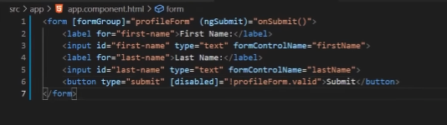
* 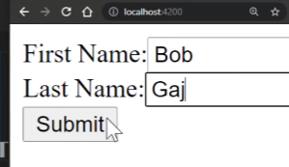

## Form Validation

* This tutorial will show you how to validate user input from the UI and display useful validation messages in both reactive and template driven forms.
* To add validation to a template driven form, you add the same validation attributes as you would with native HTML form validation.
* Angular uses directives to match these attributes with validator functions in the framework.
* 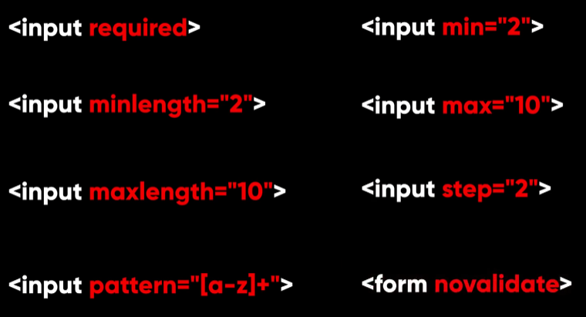
* Every time the value of a form control changes, anger runs validation, and generates either a list of validation errors that results in an invalid status or not.
* 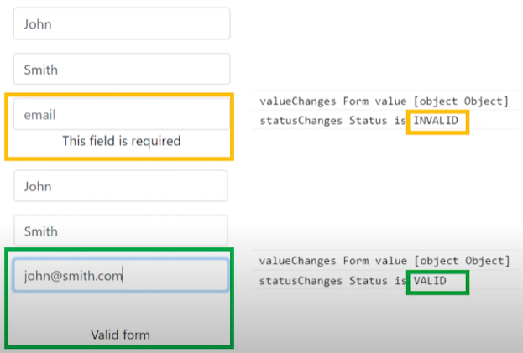 
* I'll create a name string field inside of our component class.
* 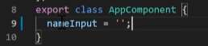
* Then in our HTML file, I'll add an input text field with required attribute min length of four.
* 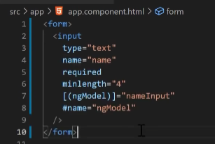
* I'm binding name input property to NgModel, and I'm exporting NgModel to a local variable called NgMmodel mirrors many of the properties of its underlying form control instance.
* So can use this in template to check for control states such as valid and dirty.
* The NgIf of the div element reveals a set of nested messages they have, but only if the name is invalid, and the control is either dirty or touched.
  + Each nested they have can present a custom message for one of the possible validation errors.
  + These are messages for acquired admin lead.
* 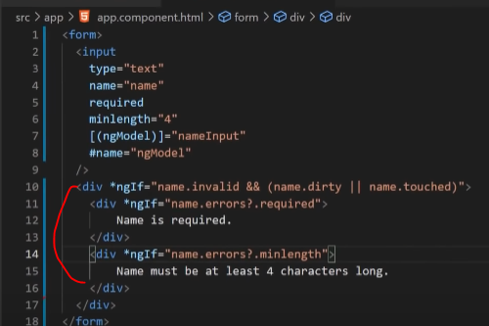
* Now if we type something and leave the field empty, we will get the validation error message.
  + 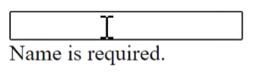
* And the same goes if we enter value less than four characters long.
  + 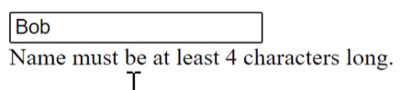

### Reactive Form

* In a reactive form, the source of truth is a component class.
* Instead of adding validators through attributes in the template, you add validator function directly to the form control model in the component class.
* The same built in validators that are available as objects in template driven forms, such as required and min length are all available to use as functions from the validator class.
* To update the validation form to be a reactive form, use some of the same built in validators.
* In this example, the name control sets up to a built in validators. validators required and validators min length.
* These validators are synchronous, so they are passed as the second argument.
  + **Notice that you can support multiple validators by passing the functions in as an array.**
* This example also adds a getter method.
* In a reactive form, you can always access any form control through the get method on its parent group.
  + But sometimes it's useful to define and getters.
  + It's shorthand for the template.
  + 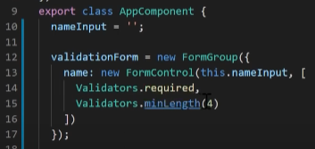
* In our template, add form group to our form.
* And now, only thing that we need to change in our template to make it reactive is to remove NgModel and to bind our name control to form control name.
* 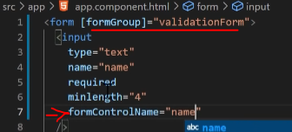
* This form differs from the template driven version in that no longer exports any directives.
* Instead, it uses the name getter defined in the component class, known as the required attribute is still present in the template.
  + Although it's not necessary for validation, it should be retained for accessibility purpose.

## HTTP Client

* We finally came to the end of this long tutorial, and we're going to cover communication using HTTPclient.
  + Without backend communication, our apps will be bad without information or instructions on the back end.
  + Most front end applications need to communicate with a server over HTTP protocol to download or upload data and access other backend services.
* Before we can use HTTP client, you need to import Angular HTTP client module.
  + Most apps do so in the root app module.
* 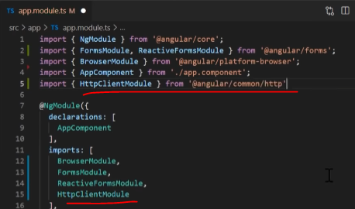
* Let's create data service.
* Most common use case is to inject HTTP client into service.
* In use it throughout the application, you can then inject HTTP client service as a dependency of an application class, as shown in this example.

### GET Method

* Now let's see how we can fetch data from a server.
* To do that, we're going to use HTTP client get method.
* First inject HTTP client into our service.
* Then create getData method and inside of this method will fetch our data.
* the get method takes two arguments the endpoint URL from which to fetch and an options object that you use to configure the request to add things like parameters to your request.
* 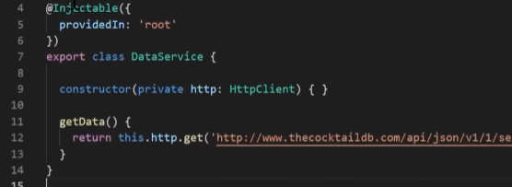
* For this tutorial, I found a free cocktail API service.
* The link will be in the description box below, enter the URL, and no additional parameters are required in this case.
* Now in our app component, we inject the data service in the constructor
* 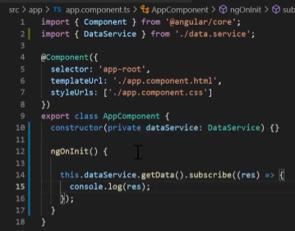
* inside of NgOnInit method, let's call our get data method.
* Because the service method returns an observable, the component subscribes to the methods return value, I'm just gonna console log the results.
* And that's how you get data from the server.
* So we need to handle errors when they come up.
* If the request fails on the server, HTTP client returns an error object instead of a successful response.
* Let's add a pipe on our get method and use catcherror to catch it.
* I'm going to log the error for development purpose and return throw error with some message.
* 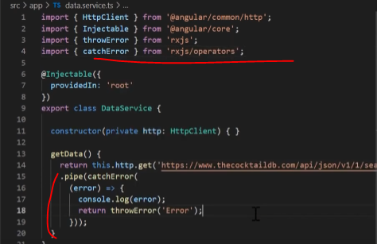
* They should be used in your obligation to show the user that his request has failed.
* Without notification, they wouldn't know what's happening.
* And don't forget to import missing packages.
* Now we can change the URL to break the request.
* And to see the error, we usually don't want to see this view in our obligations.
* But we need to be ready for that when it happens.
* HTTP client besides get also has a POST method for submitting data to server.
* For example, if you are submitting a form, we have delete requests for deleting data from database obviously, a pull request which replaces a resource with updated data.

### Authentication

* Now, most of the API's require an authentication key with their requests.
* So let's see how we can add that I found this Lord of Rings database which requires an auth key.
* Let's create HTTP options object with the headers property.
* This property will be a new HD We had this object, and we will pass two properties.
* Content Type is application JSON, which means that we're using JSON as content and authorization, where we enter our API key bearer is type of authorization, and follow by key.
  + In order to get your personal key you need to register link is in the description box below.
* And if you try to call it without passing the HTTP options, you can see that we get an error.
* What if we add authorization the request is successful.
* 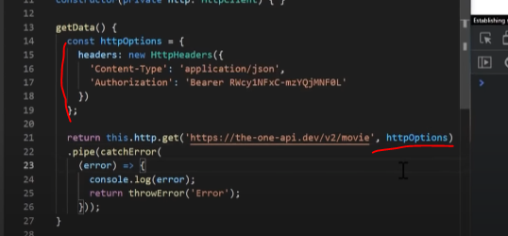
* 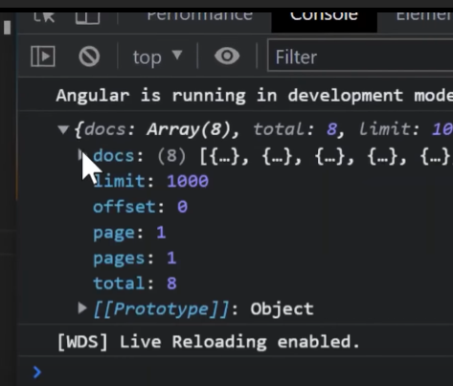
* Congratulations, you watch all the way through the end.
* This was very long tutorial and I hope you learned a lot of new things.
* Also, don't forget to subscribe to Free Code Camp.
* And if you wantto see more tutorials like this, don't forget to check out my channel.
* My name is Slobodan,and I'll see you guys in one of the next videos or tutorials.
* Take care.
* Until then.
* Chapters